Chapter 7
Future Transit Development

INTRODUCTION
This chapter presents information about future transit developments in the region that will likely take place beyond the time period covered by this TDP. The TDP plan addresses the current fleet issues, restructure and improve the local services in the region, and sets the stage for these next developments.

BRIDGE COLUMBIA EAST-WEST TRANSITWAY CONCEPT
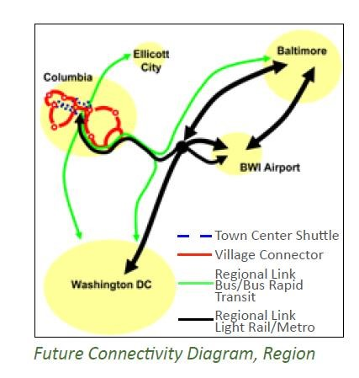
This TDP recommends a complementary transit concept for a high-frequency east-west transit corridor within Howard County, linking the Howard County General Hospital, Howard Community College, Downtown
Columbia, and Snowden Square and the Gateway employment area. As proposed, it would connect most of higher density residential and employment locations in Howard County. It would connect with the BRT, local RTA routes, and MTA services at the new Downtown Columbia Transit Center. In terms of the overall regional connectivity concept presented in Exhibit 7-3, this concept corresponds to the Village Connector shown in red, although the actual route would be different.
Exhibit 7-3: Future Regional Connectivity Concept

Background
Although not widely known, the original Final Development Plans for Columbia included a designated right-of-way for a separate “Minibus” transit network separated from the street network. These rights-of-ways are owned by the Columbia Association, and many are currently improved with the paved bicycle/pedestrian pathways. Friends of Bridge Columbia (Friends), a citizen’s group formed to advocate for a signature bridge over US 29 also called for using this transitway for a separate busway network that would connect east- and west- Columbia with a transit bridge over US 29. The proposed transitway was intended to avoid automobile traffic and improve transit speeds and reliability, support Village Centers on its route, support Downtown Columbia and Gateway redevelopment, and provide service that would be usable by the growing senior population.

Analysis of the concept revealed that the proposed corridor location addressed many of the
Friends’ goals, particularly considering projected population and employment concentrations. As the Downtown Columbia plan is implemented and Gateway redevelopment occurs, the conceptual transitway would serve the existing areas of residential and employment density, key origins and destinations, and several of the Village Centers. It is the corridor entirely within the county most likely to support high-frequency transit. However, even in projections for 2040 the densities do not reach thresholds justifying a separate busway. In addition, the right-of-way that was set-aside for the busway network is 40 to 50 feet wide. Under today’s standards, it would be completely occupied by a two-way busway with no buffer to adjoining properties. Because of the likely environmental damage, the proximity to existing housing, the likely high cost, and the current and projected level of transit ridership, the notion of a separate transitway network in its entirety is not justified for the foreseeable future.

Concept
While a separate transitway network is not warranted, the identified corridor is appropriate for the future development of improved transit. The transitway analysis showed that surface streets and highways can be used for most of the route. Current and future congestion on Route 175 between Dobbin Center Parkway past Tamar Drive could require transit priority measures such as bus-on-shoulder queue-jumper lanes and signal priority. An alternative routing that could service Oakland Mills could be implemented if the “third interchange” bridge were built across US 29. Studies for this bridge include options that would link east and west Columbia as well as provide access from US 29. Including a transit lane or transit priority on the bridge would support faster and more reliable transit. Figure 7-1 presents two conceptual routes for the Downtown to Gateway corridor utilizing different bridge options.

Continued development of this concept should add the other elements typically found in BRT like services—enhanced shelters, stops, special branding, real-time schedule information at stops—along with other locations where signal priority or other priority treatments would be advantageous. In addition the implementation of fully-electric buses on the 401 which began in 2017 (see Exhibit 7-4) sets a precedent for using specialty buses with separate branding on this route.

Figure 7-1: East-West Transitway Concepts: Using Proposed Third Interchange Bridge or Transit/Bicycle/Pedestrian Replacement Bridge
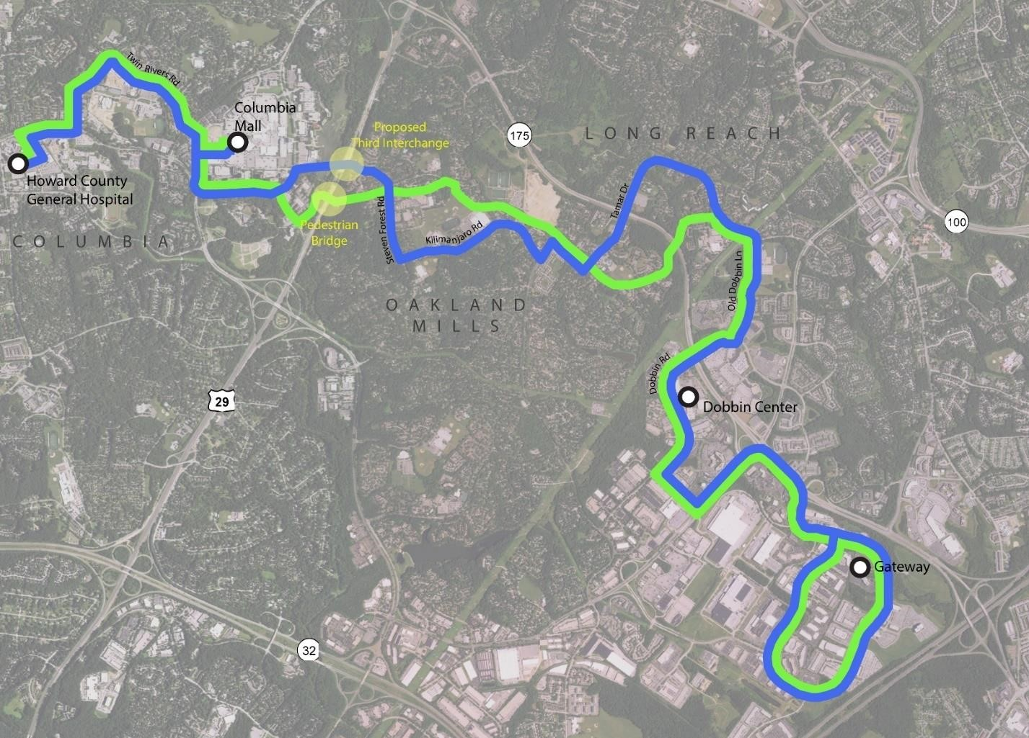

Transitway
via

Pedestrian Bridge

and ROW

T
ransitway

via Proposed 3
rd

Interchange and Surface
Streets

Building on Existing Services
Currently there are four RTA routes that operate in the area served by the Corridor—the 401, 406, 407 and 408, as shown in Figure 7-2. The 401, the 407 and the 408 are proposed to operate at 30 minute headways in the Plan. The long-range concept for the east-west transitway service would combine the 401 and the 406 into a single route, operating at higher frequencies as ridership increases with the growth of Downtown Columbia and the redevelopment of Gateway.

Figure 7-2: Existing RTA Services and the Transit right-of-way.
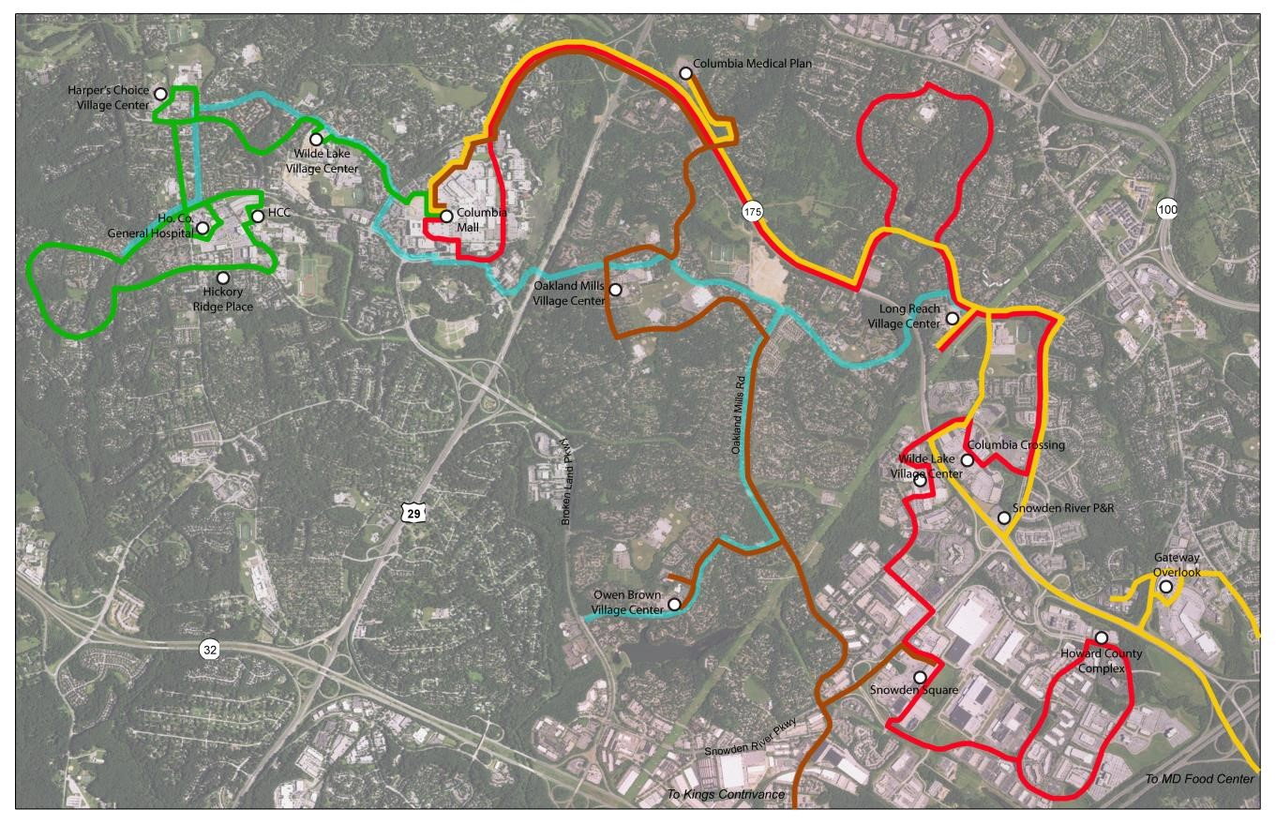

Route 401

R
oute 406

R
oute 407

R
oute 408

Transitway

Connecting with Future Services
As noted above, this proposed new east-west route would connect with the future Downtown Columbia circulator shuttle at the new Downtown Columbia Transit Center. It would also connect with the future BRT on US 29. Figure 7-3 presents a map of these proposed high frequency transit services.

Figure 7-3: Howard County’s Future High Frequency Transit Services
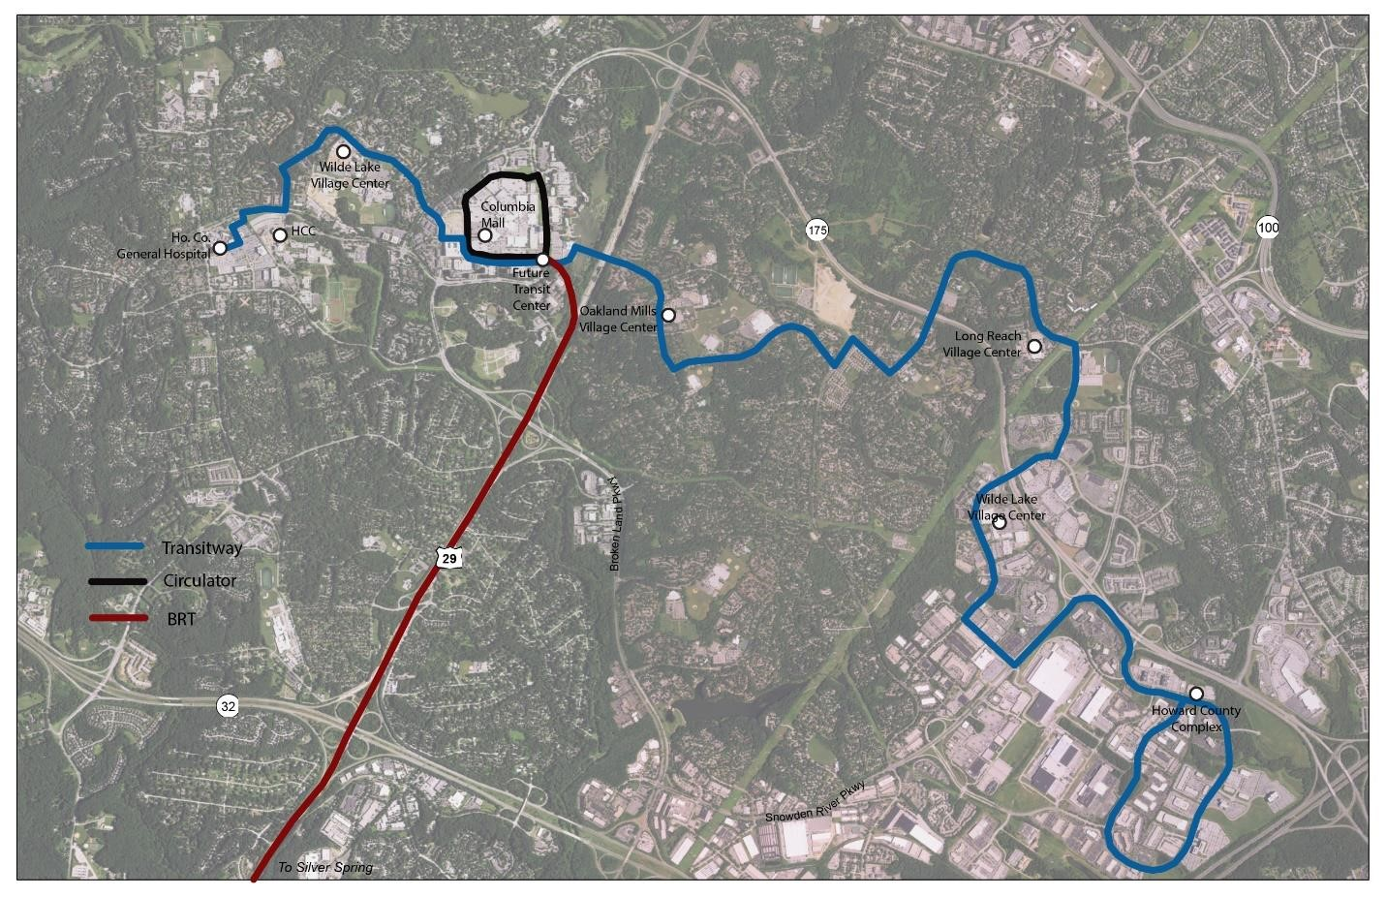

Transitwa
y

Circulator

BRT

If operated at planned Montgomery County frequencies, it would operate at 7.5 minute headways in the peak, and 15 minute headways off-peak. An east-west transit service operating at similar headways could effectively extend the impact of the BRT to much of Columbia, particularly the major activity centers.

Timing
The potential timing of implementation is linked to the future implementation of a number of elements. The Montgomery County BRT is slated to begin service from Burtonsville in 2020.
The timing of an extension to Columbia is not known, but likely be later. The Downtown
Columbia Transit Center is estimated for construction in eight to ten years. The Third Interchange Bridge is included in the Downtown Columbia plan, but there is no estimate of the date when it will be warranted. The redevelopment of the Gateway area will take a number of years, perhaps achieving most of its growth by 2040.

The development of the East-West Transitway high-frequency bus service will not likely occur during the period covered by this TDP, but it is potentially a part of the next one. At that point the basic combined east-west route could be evaluated, and perhaps implemented at current frequencies using the existing roads, perhaps with priority treatments. By then BRT service and the need for the third interchange bridge will be better understood, and there may be more certainty about the potential routing.

DOWNTOWN COLUMBIA CIRCULATOR

Howard County’s 2010 Downtown Columbia Plan recommends a circulator shuttle to reduce Downtown Columbia traffic as residents, employees and visitors “park once,” then walk or take the shuttle to other destinations in Downtown Columbia. Under the Plan’s Community
Enhancement, Program and Public Amenity (CEPPA) #23 requirements GGP (now Howard Hughes) must provide $1,000,000 towards the initial funding of a Downtown Circulator Shuttle prior to issuance of a building permit for the 5 millionth square foot of development. Issuance of a building permit for the 1.3 millionth square foot of development is expected in late 2017 or early 2018. Due to market conditions it is uncertain when a permit for the 5 millionth square foot of development will be issued but it will likely be in at least four or five years towards the end of the life of this TDP.
CEPPA #5 required a study of the shuttle to evaluate and determine appropriate levels of service and phasing in of service at various levels of development. Howard Hughes completed this study in 2011. The study’s key recommendations were (in summary):
- A Downtown Columbia circulator should begin operations when there are enough new residents in Downtown Columbia seeking such service, as determined through the results of monitoring surveys.

- A transportation demand management plan should be established for Downtown Columbia with a periodic monitoring program that can establish a clear metric(s) for when a circulator shuttle is appropriate.

- The short-term circulator should utilize existing mall and surrounding roads with approximately six stops near existing buildings and the mall. The circulator should operate on a fixed schedule, departing the transit center every 20-minutes.

- In the long-term, the circulator should extend its route to the Crescent area when new development in that area is occupied and reporting a need through the monitoring program’s surveys. Frequencies should increase to 15- minutes.

DOWNTOWN COLUMBIA TRANSIT CENTER
As noted in Chapter 6, planning is underway for a new Downtown Columbia Transit Center to serve as the central station for the BRT, RTA routes, MTA commuter bus, the Downtown Columbia shuttle. The facility will be centrally located in Downtown Columbia.

An alternatives analysis conducted for Howard County evaluated several sites, and the recommended site (known as Site 3) is located on the southside of Mall Ring Road along Little Patuxent Parkway (near Union Jacks Pub/Restaurant). The analysis call for fourteen bus bays—eight for existing RTA routes, two for RTA growth, two for MTA, and two for BRT routes. It will have sheltered waiting areas, bicycle parking, a transit information booth, facilities for driver break time (including restrooms), real-time transit information, and commuter parking for MTA routes. The facility is intended to be part of a mixed-use, mixedincome residential project developed by the Howard County Housing Commission.

Figure 7-4: Downtown Columbia Transit Center Concept
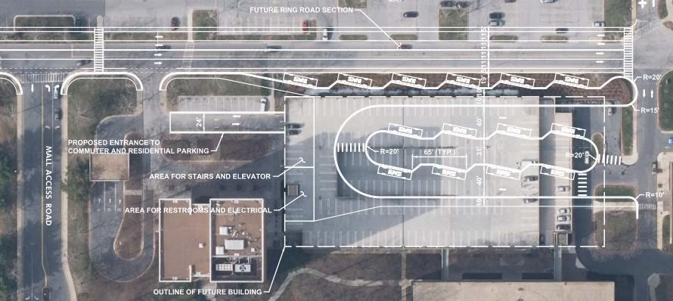

Source: Downtown Columbia Transit Center Location and Site Analysis Study

The Transit Center portion of the project will be funded from the Downtown Columbia property tax increment.

The Downtown Columbia Plan requires General Growth Properties, (now Howard Hughes Corporation) to provide the site prior to issuance of a building permit for the 1.3 million square foot development, however, the timing may be changed to coincide better with the planned redevelopment of the chosen site. As a result the implementation of the new transit center is likely to be in the eight to ten year time frame.

See separate report prepared concurrently with the TDP – Bridge Columbia Transitway Study.
Planning guidelines call for 15 housing units per acre and/or 75 employees per acre as thresholds for busway feasibility.
Howard County, Maryland, Downtown Columbia Plan: A General Plan Amendment, February 1, 2010; and Wallace Montgomery, Draft Feasibility Study for Downtown Columbia Transportation Improvements-Little Patuxent Parkway/U.S.29 Interchange, January 2012.
Downtown Columbia Downtown Transit Center and Circulator Shuttle Feasibility Study.
Downtown Columbia Transit Center –Location and Site Analysis Study, October 2017

